**IICS — EXPRESSION**

* Go to the respective project folder .
* Click new — Click Mappings — Create a mapping to deploy data integration logic that is processed on the secure agent.
* Change the Mapping name.
* Click on Source — Go to Source in the properties — Select the connection — Source type Single — Select the object/table.
* When the Mapping is created it will direct to the mapping page where we perform data transformation.
* There are many Transformation available in the Mapping — Sorting, Joiner, Router etc.
* In this project the Expression is used to Concatenate the employee First Name and Last name — Adding a new Column called Full Name.
* Drag and Drop the Expression Transformation.
* Click on Expression — Go to Expression in the properties — Add Expression — It insists to type a name to the new column — Click on Expression field — Drag and Drop the columns and perform in the expression in the Expression Box.
* Click on Target — Go to Target in the properties — Select the connection — Source type Single — Create the object/table.
* Save and Run.
* 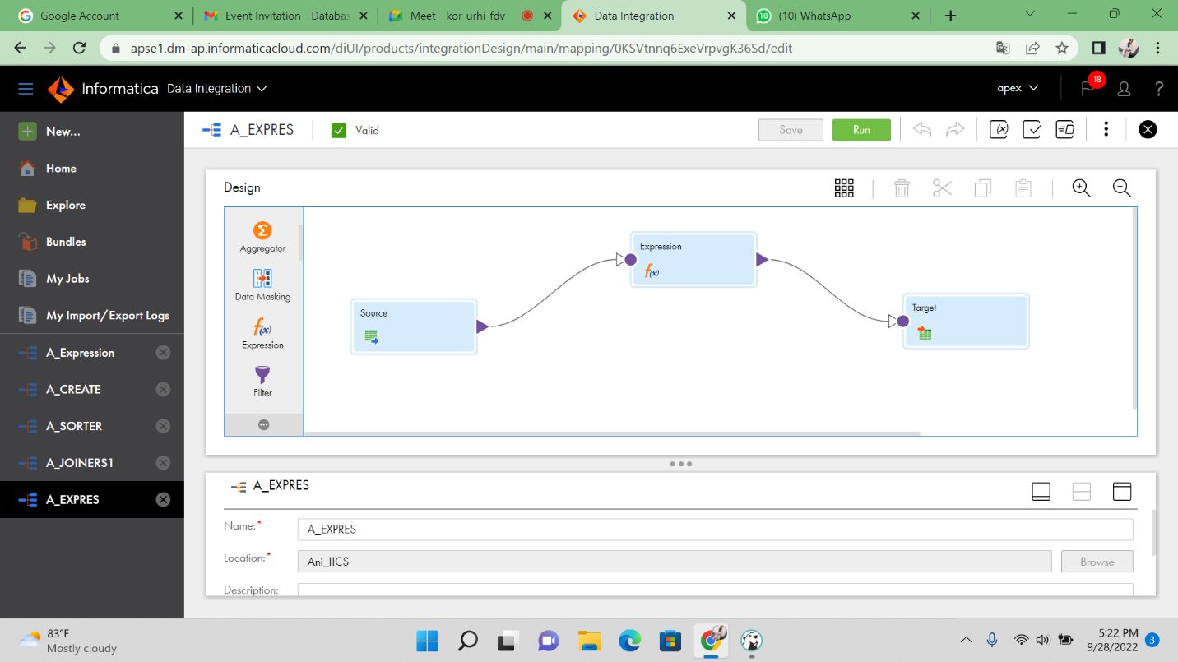Graphical user interface, text

  Description automatically generated

